EKS SETUP and CI/CD pipeline

Creating the admin server using terraform and Jenkins(CI/CD )
Step: 1 (create a repo (kubebernetes) and create a file main.tf and server-script.sh)
Admin server:- inside the admin server installing Jenkins and
provider "aws" {
region = "us-east-1"
access_key = "x"
secret_key = "x+"
}
resource "aws_instance" "instance-1" {
ami = "ami-0e86e20dae9224db8"
instance_type = "t2.medium"
key_name = "private_key_1"
subnet_id = "subnet-0bb48c1521332f654"
vpc_security_group_ids = ["sg-096e063b04175131f"]
associate_public_ip_address = true
root_block_device {
volume_size = 16
volume_type = "gp2"
delete_on_termination = true
}
user_data = file ("server-script.sh")
tags = {
Name = "admin server"
}
}
output "instance_public_ip" {
value = aws_instance.instance-1.public_ip
description = "The public IP address of the EC2 instance"
}
---------------------------------------------------------------------------------------------------------------------------------------------------------------------
server-script.sh
(installing jenkind using user_data = file("server-script.sh")
#!/bin//bash
sudo wget -O /etc/yum.repos.d/jenkins.repo \
https://pkg.jenkins.io/redhat-stable/jenkins.repo
sudo rpm --import https://pkg.jenkins.io/redhat-stable/jenkins.io-2023.key
sudo yum upgrade
sudo yum install java-17 -y
sudo yum install jenkins -y
sudo systemctl daemon-reload
sudo systemctl enable jenkins
sudo systemctl start jenkins
// installing terraform
sudo yum install -y yum-utils
sudo yum-config-manager --add-repo https://rpm.releases.hashicorp.com/AmazonLinux/hashicorp.repo
sudo yum -y install terraform
sudo hostname admin-server

Step 2:
Create folder EKS and put all file inside that such as (Jenkins, main.tf, output.tf, variables.tf)
EKS folder (Jenkins, main.tf, output.tf, variables.tf)
-----------------------------------------------------------------------------------------------------------------------
Jenkins pipeline script
pipeline {
parameters {
choice(name: 'terraformAction', choices: ['apply', 'destroy'], description: 'Choose the Terraform action to perform')
}
environment {
AWS_ACCESS_KEY_ID = credentials('AWS_ACCESS_KEY_ID')
AWS_SECRET_ACCESS_KEY = credentials('AWS_SECRET_ACCESS_KEY')
}
agent any
stages {
stage('checkout') {
steps {
dir('terraform') {
git branch: 'infra', url: 'https://github.com/ManojKRISHNAPPA/complete-cicd-project-microdegree.git'
}
}
}
stage('Plan') {
steps {
dir('eks') {
sh 'terraform init'
sh 'terraform plan -out=tfplan'
sh 'terraform show -no-color tfplan > tfplan.txt'
}
}
}
stage('Approval') {
steps {
script {
def plan = readFile 'eks/tfplan.txt'
input message: "Do you want to proceed with the Terraform action?",
parameters: [text(name: 'Plan', description: 'Please review the plan', defaultValue: plan)]
}
}
}
stage('Apply or Destroy') {
when {
expression {
return params.terraformAction == 'apply' || params.terraformAction == 'destroy'
}
}
steps {
dir('eks') {
script {
if (params.terraformAction == 'apply') {
sh 'terraform apply -input=false tfplan'
} else if (params.terraformAction == 'destroy') {
sh 'terraform destroy -auto-approve'
}
}
}
}
}
}
}

Note: To use the dir('eks') step instead of cd eks in your Jenkins pipeline, this command is used to change into the eks folder, where the Terraform file main.tf exists.
----------------------------------------------------------------------------------------------------------------------------------------------------------------------------------------
Main.tf
This is main.tf file is used to create the eks cluster using pipeline (automation). Jenkins file will trigger and create the EKS using main.tf file. Aws access and secret key will be stored in Jenkins global credential.

provider "aws" {
region = "us-east-1"
}
resource "aws_vpc" "microdegree_vpc" {
cidr_block = "10.0.0.0/16"
tags = {
Name = "microdegree-vpc"
}
}

resource "aws_subnet" "microdegree_subnet" {
count = 2
vpc_id = aws_vpc.microdegree_vpc.id
cidr_block = cidrsubnet(aws_vpc.microdegree_vpc.cidr_block, 8, count.index)
availability_zone = element(["us-east-1a", "us-east-1b"], count.index)
map_public_ip_on_launch = true
tags = {
Name = "microdegree-subnet-${count.index}"
}
}
resource "aws_internet_gateway" "microdegree_igw" {
vpc_id = aws_vpc.microdegree_vpc.id

tags = {
Name = "microdegree-igw"
}
}
resource "aws_route_table" "microdegree_route_table" {
vpc_id = aws_vpc.microdegree_vpc.id

route {
cidr_block = "0.0.0.0/0"
gateway_id = aws_internet_gateway.microdegree_igw.id
}

tags = {
Name = "microdegree-route-table"
}
}
resource "aws_route_table_association" "a" {
count = 2
subnet_id = aws_subnet.microdegree_subnet[count.index].id
route_table_id = aws_route_table.microdegree_route_table.id
}
resource "aws_security_group" "microdegree_cluster_sg" {
vpc_id = aws_vpc.microdegree_vpc.id
egress {
from_port = 0
to_port = 0
protocol = "-1"
cidr_blocks = ["0.0.0.0/0"]
}
tags = {
Name = "microdegree-cluster-sg"
}
}
resource "aws_security_group" "microdegree_node_sg" {
vpc_id = aws_vpc.microdegree_vpc.id
ingress {
from_port = 0
to_port = 0
protocol = "-1"
cidr_blocks = ["0.0.0.0/0"]
}
egress {
from_port = 0
to_port = 0
protocol = "-1"
cidr_blocks = ["0.0.0.0/0"]
}
tags = {
Name = "microdegree-node-sg"
}
}
resource "aws_eks_cluster" "microdegree" {
name = "microdegree-cluster"
role_arn = aws_iam_role.microdegree_cluster_role.arn
vpc_config {
subnet_ids = aws_subnet.microdegree_subnet[*].id
security_group_ids = [aws_security_group.microdegree_cluster_sg.id]
}
}
// eks cluster creation code below
resource "aws_eks_node_group" "microdegree" {
cluster_name = aws_eks_cluster.microdegree.name
node_group_name = "microdegree-node-group"
node_role_arn = aws_iam_role.microdegree_node_group_role.arn
subnet_ids = aws_subnet.microdegree_subnet[*].id
scaling_config {
desired_size = 3
max_size = 3
min_size = 3
}

instance_types = ["t2.large"]
remote_access {
ec2_ssh_key = var.ssh_key_name
source_security_group_ids = [aws_security_group.microdegree_node_sg.id]
}
}
resource "aws_iam_role" "microdegree_cluster_role" {
name = "microdegree-cluster-role"
assume_role_policy = <<EOF
{
"Version": "2012-10-17",
"Statement": [
{
"Effect": "Allow",
"Principal": {
"Service": "eks.amazonaws.com"
},
"Action": "sts:AssumeRole"
}
]
}
EOF
}
resource "aws_iam_role_policy_attachment" "microdegree_cluster_role_policy" {
role = aws_iam_role.microdegree_cluster_role.name
policy_arn = "arn:aws:iam::aws:policy/AmazonEKSClusterPolicy"
}
resource "aws_iam_role" "microdegree_node_group_role" {
name = "microdegree-node-group-role"

assume_role_policy = <<EOF
{
"Version": "2012-10-17",
"Statement": [
{
"Effect": "Allow",
"Principal": {
"Service": "ec2.amazonaws.com"
},
"Action": "sts:AssumeRole"
}
]
}
EOF
}
resource "aws_iam_role_policy_attachment" "microdegree_node_group_role_policy" {
role = aws_iam_role.microdegree_node_group_role.name
policy_arn = "arn:aws:iam::aws:policy/AmazonEKSWorkerNodePolicy"
}
resource "aws_iam_role_policy_attachment" "microdegree_node_group_cni_policy" {
role = aws_iam_role.microdegree_node_group_role.name
policy_arn = "arn:aws:iam::aws:policy/AmazonEKS_CNI_Policy"
}
resource "aws_iam_role_policy_attachment" "microdegree_node_group_registry_policy" {
role = aws_iam_role.microdegree_node_group_role.name
policy_arn = "arn:aws:iam::aws:policy/AmazonEC2ContainerRegistryReadOnly"
}

Output.tf
it will display the out in terraform in terminal (ex: IP address)
output "cluster_id" {
value = aws_eks_cluster.microdegree.id
}
output "node_group_id" {
value = aws_eks_node_group.microdegree.id
}
output "vpc_id" {
value = aws_vpc.microdegree_vpc.id
}
output "subnet_ids" {
value = aws_subnet.microdegree_subnet[*].id
}

Variable.tf

A variable file (like variables.tf) in Terraform is used to store values such as the SSH key name in a reusable, flexible way. Instead of hardcoding details directly in the code, variables let you easily change values for different environments or users without changing the main configuration. It also allows setting a default value to simplify deployment. This helps keep Terraform code clean, modular, and easy to maintain.
So, the variable "ssh_key_name" lets you specify which SSH key will be used to securely access instances, and you can change it whenever needed without editing the core code.

variable "ssh_key_name" {
description = "The name of the SSH key pair to use for instances"
type = string
default = "jun26"

Step: 3
Jenkins configuration
Frist we have to the access key and secret key in Jenkins using mange Jenkins.
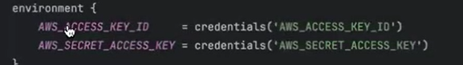

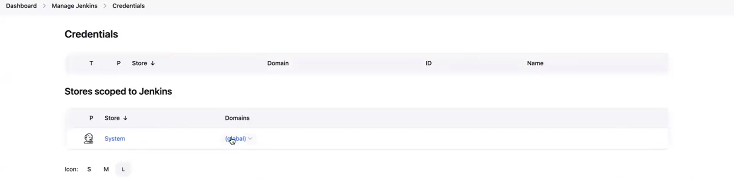
Manage Jenkins credential domain(global)- add credential new credential
Access key:
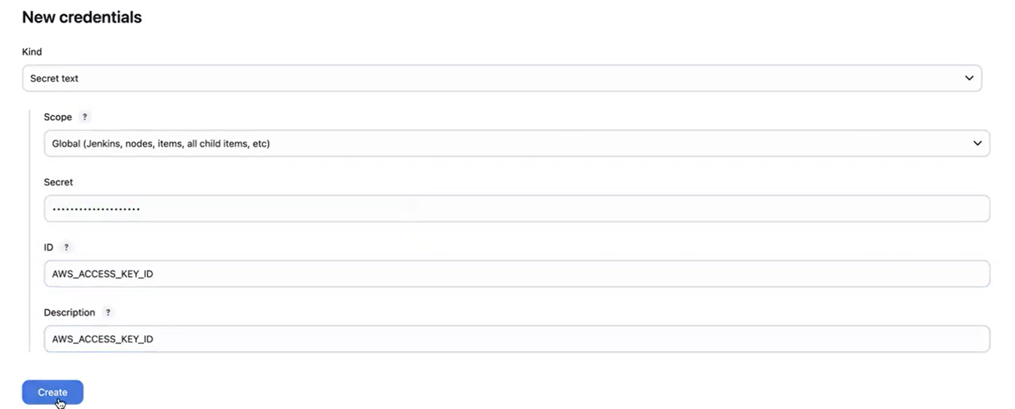

Secret key:
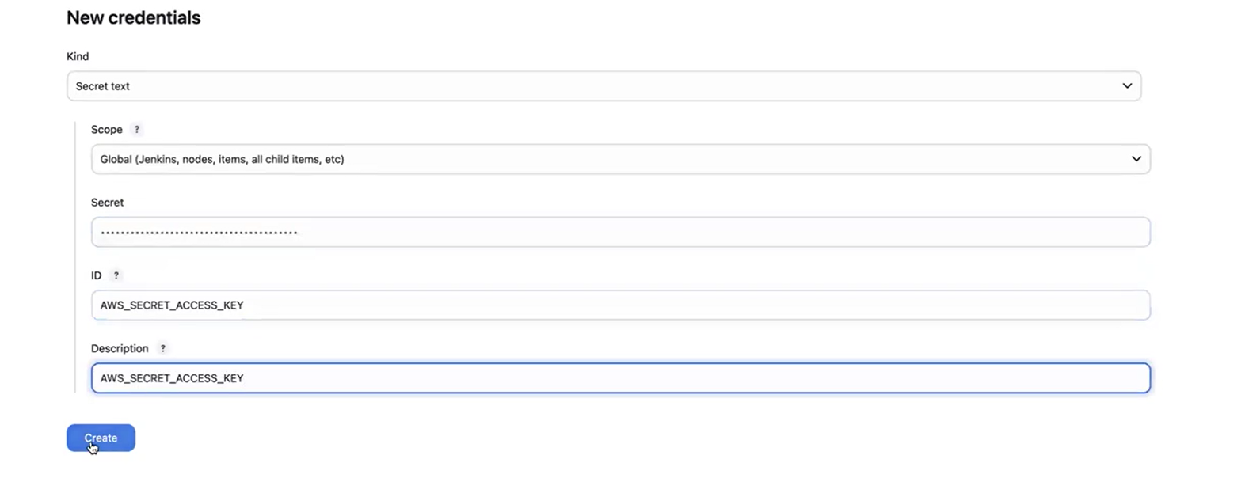

Docker hub credential
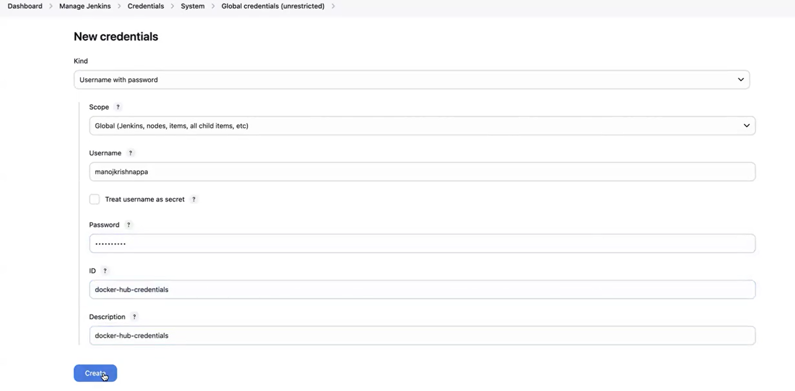
---------------------------------------------------------------------------------------------------------------------------------------------------
Step: 4
Installing AWS cli on the server
curl "https://awscli.amazonaws.com/awscli-exe-linux-x86_64.zip" -o "awscliv2.zip"
unzip awscliv2.zip
sudo ./aws/install

aws configure

---------------------------------------------------------------------------------

Step 5:

Install kubectl on server or admin server

curl -O https://s3.us-west-2.amazonaws.com/amazon-eks/1.29.3/2024-04-19/bin/linux/amd64/kubectl
chmod +x ./kubectl
mv ./kubectl /usr/local/bin
kubectl version –client

Step 6:

Attaching EKs role to the admin server

An EKS IAM role is attached to the Kubernetes cluster to allow the cluster to securely manage AWS resources and perform necessary operations like managing nodes, networking, and load balancers. It grants the cluster permission to interact with AWS services such as EC2 and EBS. This role also enables fine-grained access control by linking AWS IAM with Kubernetes service accounts, allowing pods to access AWS resources securely. In summary, attaching the EKS role ensures secure, automated, and efficient management of infrastructure needed for the Kubernetes cluster to operate smoothly on AWS.

Step 7:

Installing Docker
-----------------------------------------------------------------------------------------
#!/bin/bash
echo << EOF
"=========================================================="
"|| Set up Docker's Apt repository ............... ||"
"=========================================================="
EOF
#Set up Docker's Apt repository
# Add Docker's official GPG key:
sudo apt-get update -y
sudo apt-get install ca-certificates curl gnupg -y
sudo install -m 0755 -d /etc/apt/keyrings
curl -fsSL https://download.docker.com/linux/ubuntu/gpg | sudo gpg --dearmor -o /etc/apt/keyrings/docker.gpg
sudo chmod a+r /etc/apt/keyrings/docker.gpg

# Add the repository to Apt sources:
echo \
"deb [arch="$(dpkg --print-architecture)" signed-by=/etc/apt/keyrings/docker.gpg] https://download.docker.com/linux/ubuntu \
"$(. /etc/os-release && echo "$VERSION_CODENAME")" stable" | \
sudo tee /etc/apt/sources.list.d/docker.list > /dev/null
sudo apt-get update -y

echo << EOF
"=========================================================="
"|| Docker's Apt repository is completed........... ||"
"=========================================================="
EOF

echo << EOF
"=========================================================="
"|| Install the Docker packages.................... ||"
"=========================================================="
EOF

sudo apt-get install docker-ce docker-ce-cli containerd.io docker-buildx-plugin docker-compose-plugin -y

echo << EOF
"=========================================================="
"|| Install is completed .................... ||"
"=========================================================="
EOF

### it is for ubantu server

dockerStatus=$(systemctl status docker | awk '/Active/ {print $3}' | tr -d "[()]")
dockerVersion=$(docker -v | awk '/version/ {print $3}' | tr -d ",")

echo "The Docker status is $dockerStatus"
echo "The Docker version is $dockerVersion"

--------------------------------------------------------------------------

Step 8:
Adding Jenkins to docker group
cat/etc/group
Usermod –aG docker jenkins
Goto Visudo file
Jenkins ALL= (ALL: ALL) ALL
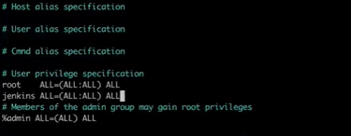
Init 8 (restart the server)
Go to Jenkins dashboard
Tools section
JDK installation
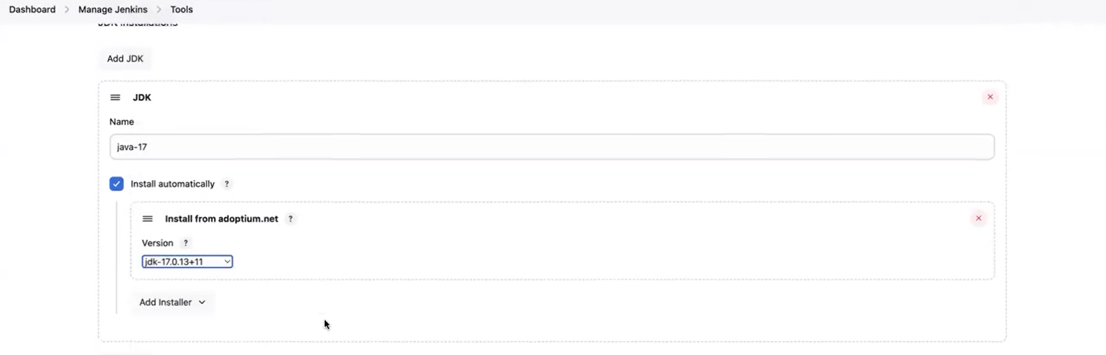
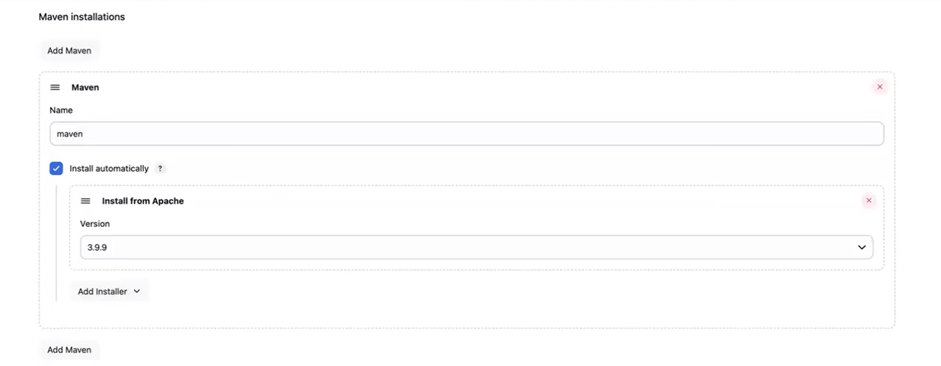
---------------------------------------------------------------------------------------------------------
Step 9:

Do the pipeline configuration. Integrate the Jenkins with git hub repos
install al necessary plugins.
Stageview, eclipse, maven, config file provider, Docker.kubernetes, kubernetes credential, kubernetes CLi, kubernetes credential provier, kubernete pipeline , Docker pipeline.

config file provider:-
The Config File Provider Plugin in Jenkins lets you store and manage configuration files like settings or scripts inside Jenkins. You can then easily use these files in your build jobs without manually adding them each time. It makes managing and sharing config files simple and helps keep builds consistent.
For example, you can define a Maven settings file once, then use it in multiple jobs by referencing it in the Jenkins Pipeline. This avoids copying files around and keeps everything centralized and easy to update. It’s like having a toolbox of config files ready to use whenever needed in your builds.

Step 10:
Install trivy
sudo apt-get update
wget -qO - https://aquasecurity.github.io/trivy-repo/deb/public.key | sudo apt-key add -
echo "deb https://aquasecurity.github.io/trivy-repo/deb stable main" | sudo tee -a /etc/apt/sources.list.d/trivy.list
sudo apt-get update
sudo apt-get install trivy
trivy --version

---------------------------------------------------------------------------------------------------------Note: we have created EKS cluster on adminserver using terraform and installed required tools such as Jenkins, Docker, kubectl etc.

Once EKS cluster is launched

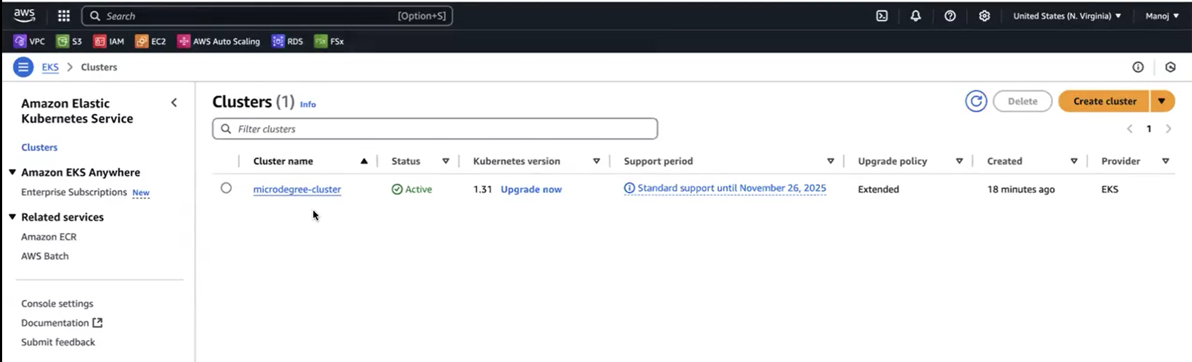

Node group are running in Ec2 instance.
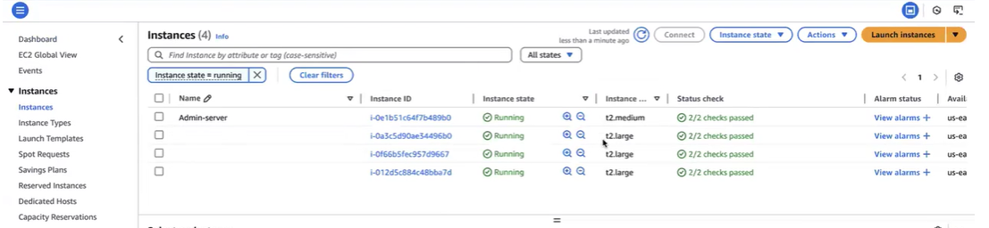
security group and auto scaling group also created.
As soon as we create the eks cluster, we have to create service account, role and assign that role, and create a secret for service account and generate a token.
token generated by service account using that id application need deploy.

STEP 11:-
Service account
first we have update
Aws eks update-kubeconfig –region us-east-1 –name <ekscluster name>

The command aws eks update-kubeconfig --region us-east-1 --name <ekscluster name> is used to set up your local Kubernetes tool (kubectl) so it can connect and manage your Amazon EKS cluster.
In simple terms:
It updates or creates a configuration file called kubeconfig on your computer.
This file tells kubectl how to communicate with your specific EKS cluster (identified by the name and region).
After running this, you can run kubectl commands to control your Kubernetes cluster (like checking pods, deploying apps).
Think of it as telling your computer: "Here is the information to securely talk to my cloud Kubernetes cluster named <ekscluster name> in the us-east-1 region."
You must have kubectl installed before running this command, and it uses your AWS credentials to authenticate.
This command saves the cluster info locally so you don't have to enter it every time manually and lets you easily manage your EKS cluster through kubectl.

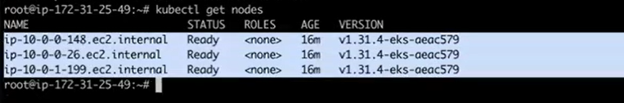
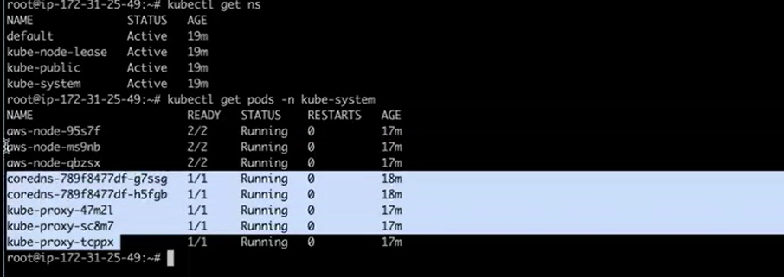
Here , there is no control plane in this cluster , because
The control plane in an Amazon EKS cluster is there but you don’t see or manage it directly because AWS takes care of it for you. AWS runs the control plane (which includes components like the Kubernetes API server and etcd) in its own secure and reliable infrastructure across multiple data centers.
This means AWS handles all the hard work like making sure the control plane is always up, fixing it if something breaks, and scaling it when needed. You just use the endpoint AWS provides to talk to your cluster without worrying about the control plane details.
In simple terms:
The control plane exists but is fully managed by AWS behind the scenes.
You don’t have to run or maintain the control plane servers.
AWS makes sure it is always available and secure.
You interact with your cluster using the control plane endpoint that AWS manages.

Create a folder
Mkdir kube

Create a namespace
Kubectl create ns microdegree

Create a service account
Serviceaccount.yml
---
apiVersion: v1
kind: ServiceAccount
metadata:
name: jenkins
namespace: microdegree
---
This YAML code creates a service account in Kubernetes named "jenkins" inside the "microdegree" namespace.
Gives a unique identity to processes running inside Pods in the "microdegree" namespace.
Allows those Pods to securely communicate with the Kubernetes API and perform actions allowed by the permissions of the service account.
Common use: Assigning this service account to Jenkins Pods so Jenkins can deploy apps, manage resources, or perform CI/CD tasks securely in the cluster.
By creating and assigning specific service accounts, you control what automated tools can do inside Kubernetes, helping keep operations safe and organized.
Kubectl apply –f Serviceaccount.yml

Note:
Kubernetes has a default service account called "default" in every namespace. When you create a Pod and do not specify a service account, Kubernetes automatically assigns the "default" service account from that namespace to the Pod. This default account has very limited permissions unless you explicitly grant it more, helping keep your cluster secure by default.
This is default
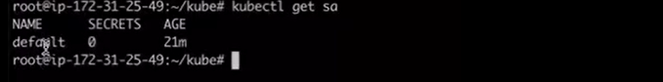
This is created by user
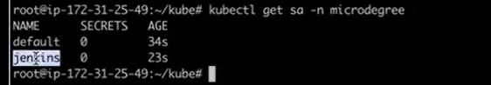

Step 12:
Create the role for service account.
It same like give the permission IAM such as read, write, delete, and update.
We attached role to Jenkins service account
Here giving full access to service account. It works same like IAM
Vi role.yml
apiVersion: rbac.authorization.k8s.io/v1
kind: Role
metadata:
name: app-role
namespace: microdegree
rules:
- apiGroups:
- ""
- apps
- autoscaling
- batch
- extensions
- policy
- rbac.authorization.k8s.io
resources:
- pods
- secrets
- componentstatuses
- configmaps
- daemonsets
- deployments
- events
- endpoints
- horizontalpodautoscalers
- ingress
- jobs
- limitranges
- namespaces
- nodes
- pods
- persistentvolumes
- persistentvolumeclaims
- resourcequotas
- replicasets
- replicationcontrollers
- serviceaccounts
- services
verbs: ["get", "list", "watch", "create", "update", "patch", "delete"]
RBAC (Role-Based Access Control) in Kubernetes is a way of controlling who can do what in your cluster by assigning roles and permissions to users, groups, or service accounts. Instead of letting everyone do everything, RBAC lets you decide which actions (like reading, creating, or deleting resources) are allowed for each person or process.
Key ideas:
Roles: Define a list of permissions for certain actions (e.g., read pods, create deployments) inside a specific namespace.
ClusterRoles: Like roles, but their permissions apply to the whole cluster and all namespaces.
RoleBindings and ClusterRoleBindings: Link users, groups, or service accounts to roles or cluster roles, giving them the permissions defined.
For example, you can create a "read-only" role and assign it to a user so they can only view resources, not change or delete them. This helps enforce security by making sure everyone and every tool only has access needed for their job—nothing more.

Vi role.yml

It includes permissions on many common resource types like pods, secrets, deployments, services, configmaps, jobs, ingress, nodes, persistent volumes, and more.
The verbs allowed are comprehensive, covering read and write operations: get, list, watch, create, update, patch, and delete.
This Role is namespace-scoped, i.e., permissions apply only within the microdegree namespace.
This Role is suitable for an application or service account requiring wide-ranging management capabilities within a single namespace but not cluster-wide access. For example, this Role would support a CI/CD pipeline or an operator managing workloads and resources in that namespace securely.
If you plan to bind this Role, use a RoleBinding to a user, group, or service account in the same namespace. For multi-namespace or cluster-wide roles, consider ClusterRole and ClusterRoleBinding instead.

Kubectl apply –f role.yml

Step: 13
We need bind with Jenkins account
Vi rolebinding.yml

apiVersion: rbac.authorization.k8s.io/v1
kind: RoleBinding
metadata:
name: app-rolebinding
namespace: microdegree
roleRef:
apiGroup: rbac.authorization.k8s.io
kind: Role
name: app-role
subjects:
- namespace: microdegree
kind: ServiceAccount
name: jenkins

A RoleBinding named app-rolebinding in the microdegree namespace connects the app-role Role to the jenkins ServiceAccount in that namespace. This grants the Jenkins ServiceAccount all the permissions defined in the app-role Role but only within the microdegree namespace. It allows Jenkins to perform actions like creating, updating, deleting, and viewing Kubernetes resources (pods, secrets, deployments, etc.) within that namespace.
In short, RoleBinding links a Role's permissions to a user or service account inside a namespace, enabling scoped access for automation or CI/CD tasks securely within that namespace. This is a common Kubernetes RBAC pattern to manage permissions safely at a namespace level.

Kubectl apply –f rolebinding.yml
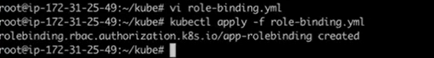

Step: 14
Service token

A service account token in Kubernetes is a secure token (usually a signed JSON Web Token or JWT) that authenticates applications or pods to the Kubernetes API server. Its main purpose is to enable workloads running in a pod to prove their identity and securely access the Kubernetes API according to the permissions assigned to their service account.
Key points about service account tokens:
They authenticate pods securely without manual credentials.
Tokens can be short-lived and automatically rotated for better security.
They enforce fine-grained access control using RBAC based on the service account.
Mounted automatically into pods for seamless API interaction.
Avoid long-lived tokens where possible to reduce security risks.

In essence, service account tokens allow safe, automated, and controlled API access from within the cluster by workloads, preventing the need for embedding user credentials inside pods and reducing attack surfaces.

Generating service token
Servicetoken.ymal

apiVersion: v1
kind: Secret
metadata:
name: mysecretname
namespace: microdegree
annotations:
kubernetes.io/service-account.name: jenkins
type: kubernetes.io/service-account-token

Here is a simple explanation of each part of your Kubernetes Secret YAML:
kind: Secret: This says you are creating a Secret, a special object to store sensitive info.
metadata: This section stores identifying details about the Secret.
name: mysecretname: The Secret's name, so you can refer to it.
namespace: microdegree: The space or project in your cluster where the Secret lives.
annotations: Extra labels to describe the Secret.
kubernetes.io/service-account.name: jenkins: Links this Secret to the jenkins service account. This means the Secret will store a token for jenkins.
type: kubernetes.io/service-account-token: This type tells Kubernetes that this Secret holds a service account's login token.
In short, this YAML creates a Secret to hold a special token that lets anything running as the jenkins service account prove who it is and safely talk to the Kubernetes API within the "microdegree" namespace. Kubernetes handles filling this Secret with the token automatically.
Kubectl apply –f Servicetoken.ymal –n <namespace>

Kubectl apply –f Servicetoken.ymal –n microdegree

Kubectl get secret <name of the secret> –n <namespace>

Kubectl get secret mysecretname –n microdegree

Kubectl describe secret mysecretname –n microdegree

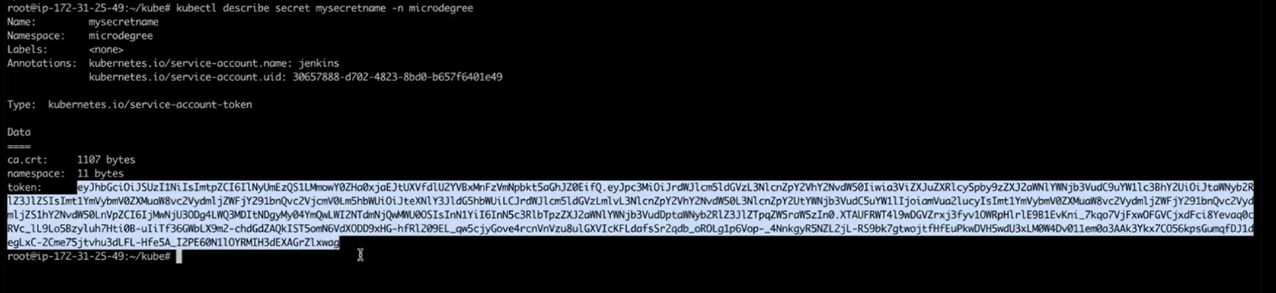

Copy the token and we have to add that token Jenkins for deployment.

Goto Jenkins credential global add credential

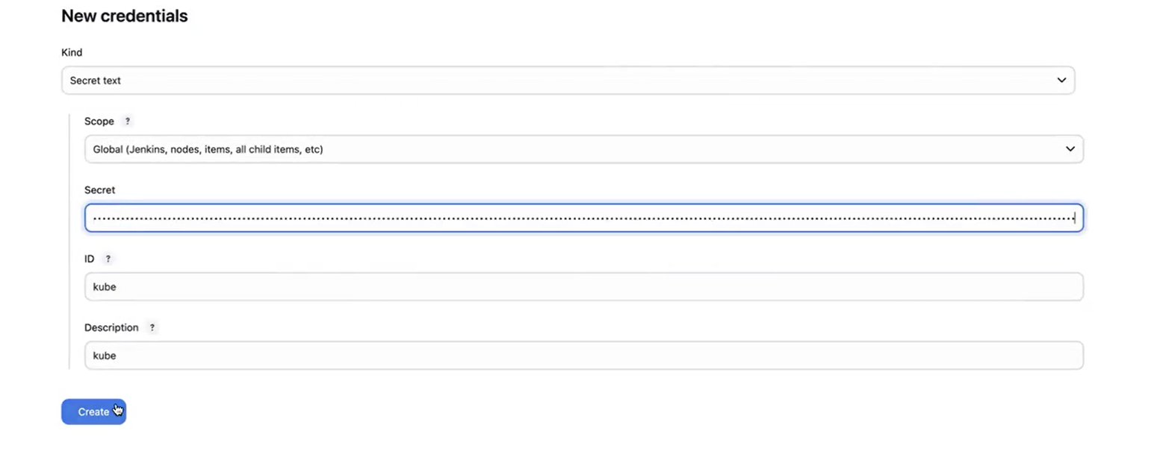
-------------------------------------------------------------------------------------------------------
Step: 15
Go to inside pipeline which used to create the eks using terraform versioning.
- We need to create the pipeline syntax:
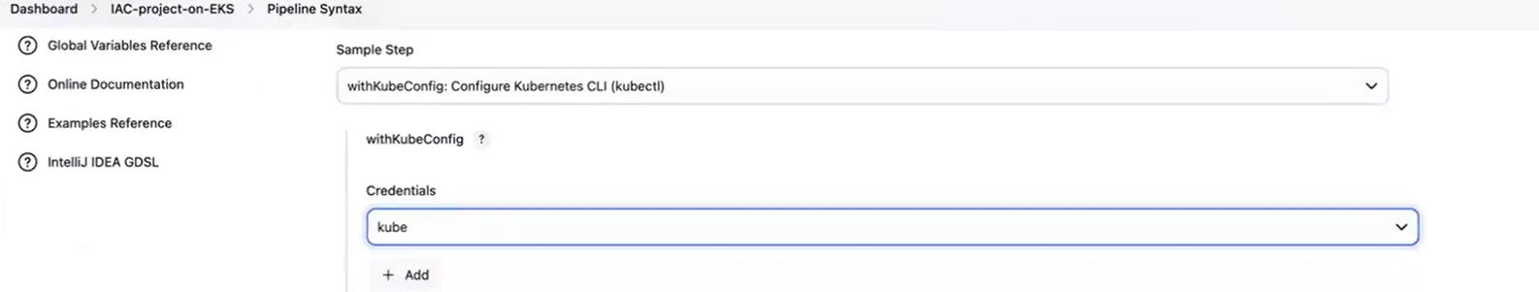

Need to add kubernetes server endpoint
Goto EKS cluster overview API server endpoint
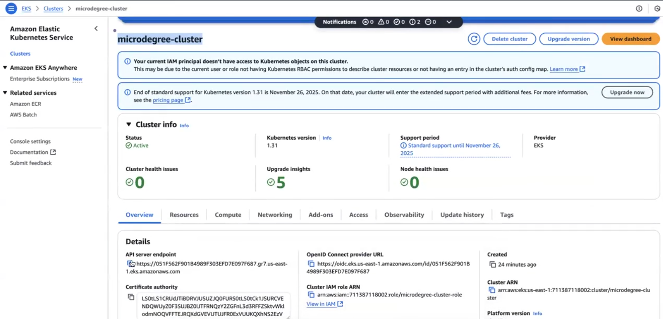
Cluster name: microdegree-cluster
Namespace: microdegree
Generate pipeline script
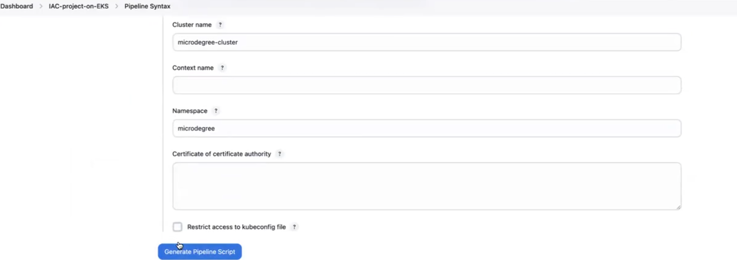

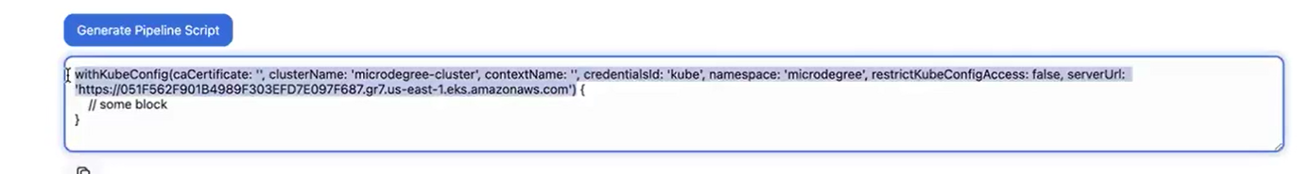
Copy the script to go to Jenkins file paste in below path
The line star with withkubeconfig replace the above script no other lines
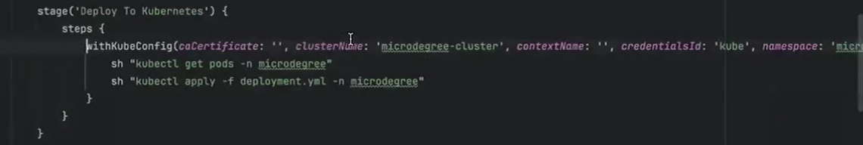
Note: This Jenkins pipeline block simply checks the status of your app in Kubernetes by listing all pods and services in the "microdegree" namespace. It connects to the specified Kubernetes cluster using the given credentials and runs these commands securely inside that cluster. This helps verify that your deployment is running correctly.
-------------------------------------------------------------------------------------------------------
Step 16 :
Post block
This Jenkins post block sends an email notification after every build, no matter if it succeeds or fails. It creates a colored email showing the job name, build number, and pipeline status (green for success, red for failure). The email includes a link to the Jenkins build console and attaches a file named trivy-image-report.html. The email is sent to and from manojdevopstest@gmail.com in HTML format.
In short, it automatically emails you the build result with details and attachments after every pipeline run.
We generate the app password. It like password for mail that we have put is Jenkins credential. Adding Gmail address in Jenkins.
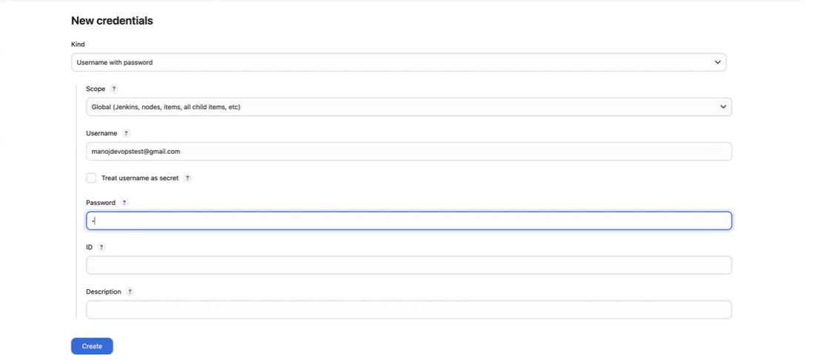
post {
always {
script {
def jobName = env.JOB_NAME
def buildNumber = env.BUILD_NUMBER
def pipelineStatus = currentBuild.result ?: 'UNKNOWN'
def bannerColor = pipelineStatus.toUpperCase() == 'SUCCESS' ? 'green' : 'red'
def body = """
<html>
<body>
<div style="border: 4px solid ${bannerColor}; padding: 10px;">
<h2>${jobName} - Build ${buildNumber}</h2>
<div style="background-color: ${bannerColor}; padding: 10px;">
<h3 style="color: white;">Pipeline Status: ${pipelineStatus.toUpperCase()}</h3>
</div>
<p>Check the <a href="${BUILD_URL}">console output</a>.</p>
</div>
</body>
</html>
"""
emailext (
subject: "${jobName} - Build ${buildNumber} - ${pipelineStatus.toUpperCase()}",
body: body,
to: 'manojdevopstest@gmail.com',
from: 'manojdevopstest@gmail.com',
replyTo: 'manojdevopstest@gmail.com',
mimeType: 'text/html',
attachmentsPattern: 'trivy-image-report.html'
)
}
}
}

Go to system

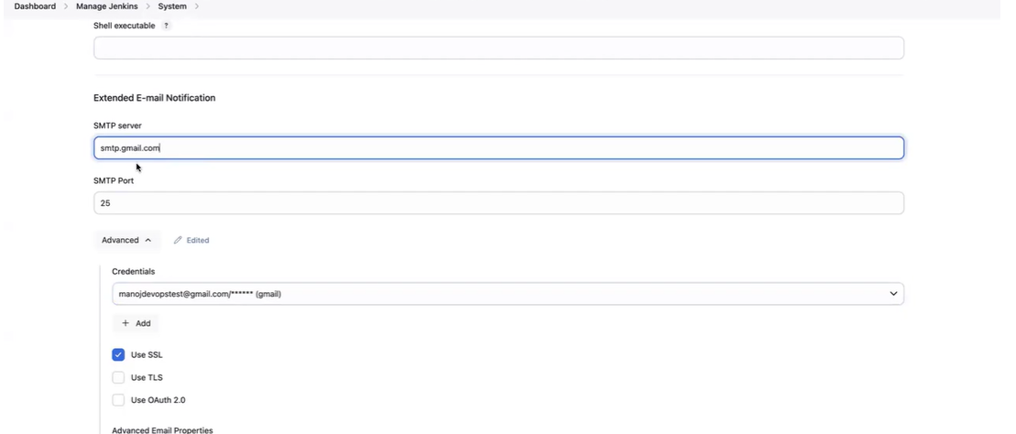
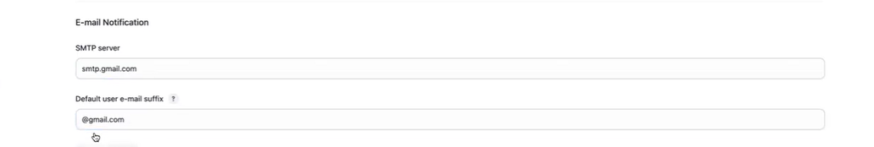
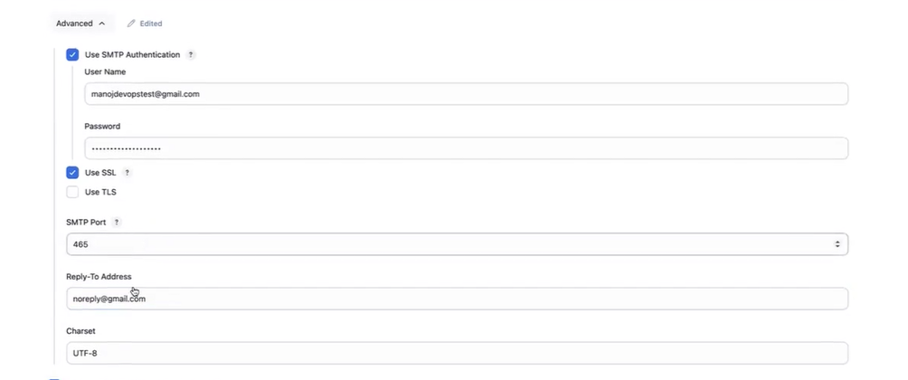
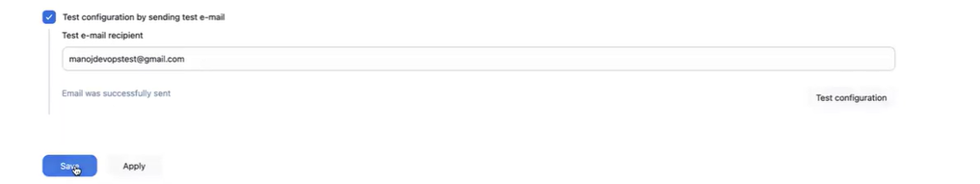

Note:
Till ,here we have create admin server using terraform and git. It is automate way of creating server and done configurations. Install required tools and plugins.
Next we have create one more pipeline for application deployment using Kubernetes.

Pipeline for build the project Java application

- Create a pipeline

- Jenkins pipeline script

pipeline {
agent any

environment {
IMAGE_NAME = "manojkrishnappa/fullstack:${GIT_COMMIT}"
AWS_REGION = "us-east-1"
CLUSTER_NAME = "microdegree-cluster"
NAMESPACE = "microdegree"
}

tools {
jdk 'java-17'
maven 'maven'
}

stages {
stage('Git Checkout') {
steps {
git branch: 'main', url: 'https://github.com/ManojKRISHNAPPA/complete-cicd-project-microdegree.git'
}
}

stage('Compile') {
steps {
sh "mvn compile"
}
}

stage('Build') {
steps {
sh "mvn package"
}
}

stage('sonarqube-stage'){
steps{
sh"""
mvn sonar:sonar \
-Dsonar.projectKey=devops \
-Dsonar.host.url=http://3.90.207.159:9000 \
-Dsonar.login=3bc7e2fd3433144539118dc582575ad22bcd2d0d
"""
}
}
stage('Build & Tag Docker Image') {
steps {
script {
sh 'printenv'
sh "docker build -t manojkrishnappa/fullstack:${GIT_COMMIT} ."
}
}
}

stage('Docker Image Scan') {
steps {
script {
sh "trivy image --format table -o trivy-image-report.html manojkrishnappa/fullstack:${GIT_COMMIT}"
}
}
}

stage('Login to Docker Hub') {
steps {
script {
withCredentials([usernamePassword(credentialsId: 'docker-hub-credentials', usernameVariable: 'DOCKER_USERNAME', passwordVariable: 'DOCKER_PASSWORD')]) {
sh "echo $DOCKER_PASSWORD | docker login -u $DOCKER_USERNAME --password-stdin"
}
}
}
}

stage('Push Docker Image') {
steps {
script {
sh "docker push manojkrishnappa/fullstack:${GIT_COMMIT}"
}
}
}

stage('Updating the Cluster') {
steps {
script {
sh "aws eks update-kubeconfig --region ${AWS_REGION} --name ${CLUSTER_NAME}"
}
}
}

stage('Deploy To Kubernetes') {
steps {
withKubeConfig(caCertificate: '', clusterName: 'microdegree-cluster', contextName: '', credentialsId: 'kube', namespace: 'microdegree', restrictKubeConfigAccess: false, serverUrl: 'https://AB2AD8E7E396070F02E8CEC4D6A0D7E9.gr7.us-east-1.eks.amazonaws.com') {
sh "sed -i 's|replace|${IMAGE_NAME}|g' deployment.yml"
sh "kubectl apply -f deployment.yml -n ${NAMESPACE}"
}
}
}

stage('Verify the Deployment') {
steps {
withKubeConfig(caCertificate: '', clusterName: 'microdegree-cluster', contextName: '', credentialsId: 'kube', namespace: 'microdegree', restrictKubeConfigAccess: false, serverUrl: 'https://AB2AD8E7E396070F02E8CEC4D6A0D7E9.gr7.us-east-1.eks.amazonaws.com') {
sh "kubectl get pods -n microdegree"
sh "kubectl get svc -n microdegree"
}
}
}
}

post {
always {
script {
def jobName = env.JOB_NAME
def buildNumber = env.BUILD_NUMBER
def pipelineStatus = currentBuild.result ?: 'UNKNOWN'
def bannerColor = pipelineStatus.toUpperCase() == 'SUCCESS' ? 'green' : 'red'

def body = """
<html>
<body>
<div style="border: 4px solid ${bannerColor}; padding: 10px;">
<h2>${jobName} - Build ${buildNumber}</h2>
<div style="background-color: ${bannerColor}; padding: 10px;">
<h3 style="color: white;">Pipeline Status: ${pipelineStatus.toUpperCase()}</h3>
</div>
<p>Check the <a href="${BUILD_URL}">console output</a>.</p>
</div>
</body>
</html>
"""

emailext (
subject: "${jobName} - Build ${buildNumber} - ${pipelineStatus.toUpperCase()}",
body: body,
to: 'manojdevopstest@gmail.com',
from: 'manojdevopstest@gmail.com',
replyTo: 'manojdevopstest@gmail.com',
mimeType: 'text/html',
attachmentsPattern: 'trivy-image-report.html'
)
}
}
}
}

